**PROJECT DEVELOPMENT DELIVERY OF SPRINT 3**

|  |  |
| --- | --- |
| Date | 18 November 2022 |
| Team ID | PNT2022TMID50586 |
| Project Name | Real-Time River Water Quality Monitoring and Control System |

# SPRINT DESCRIPTION

In this Sprint, we completely explained about our executed NODE-RED PLATFORM with relevant Screenshots.

# NODE-RED SERVICE

After Registering IBM Watson Iot Platform, now we move on to the Node-Red Service.

Here we are about to create the User Interface through Node-Red All the requirements for the project are done in this platform

# NODE-RED DEVICE FLOW

5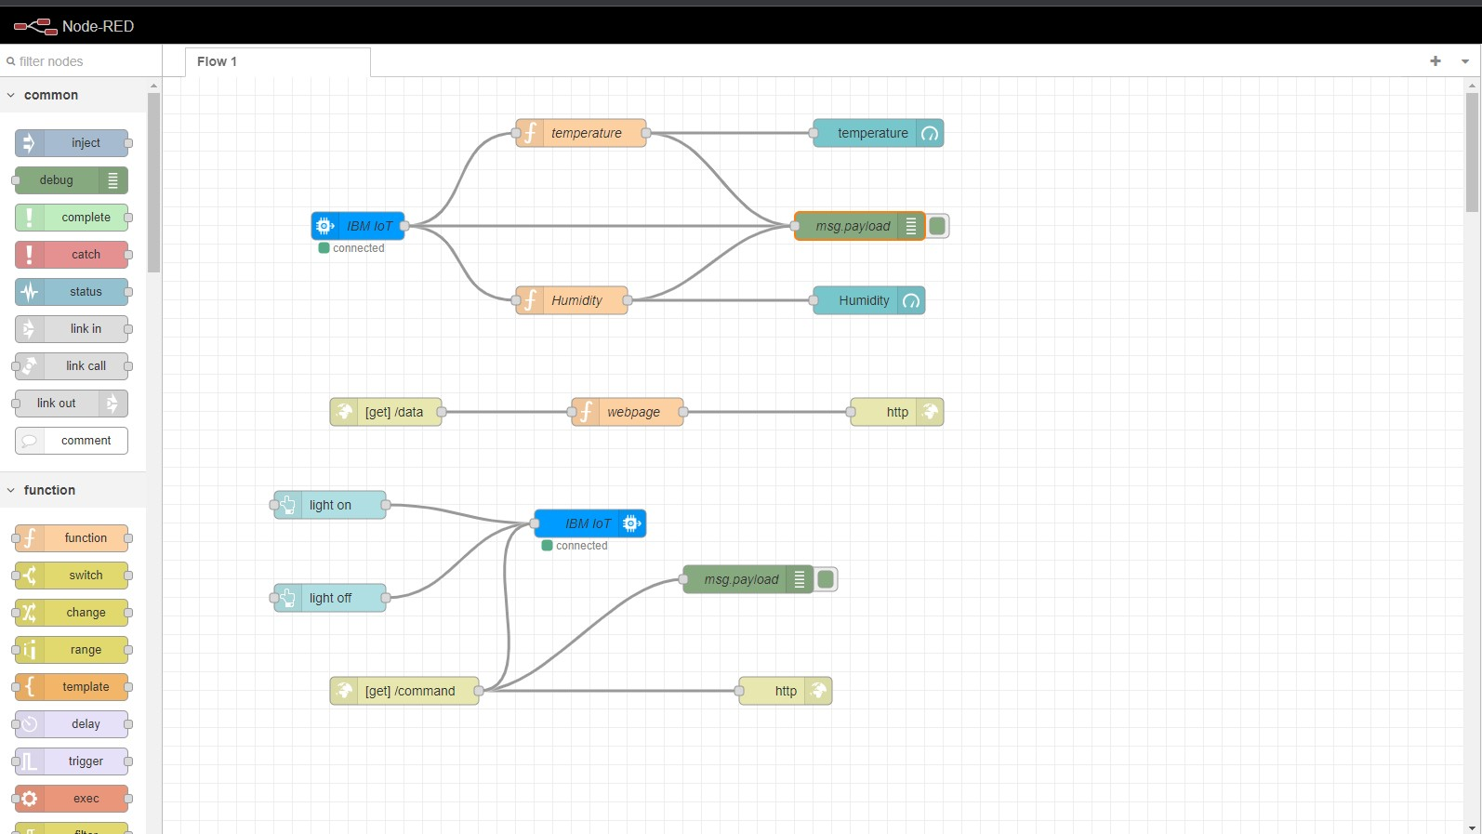

Above displayed is the circuit flow for the WEB UI and APP DEVELOPMENT

# DASHBOARD

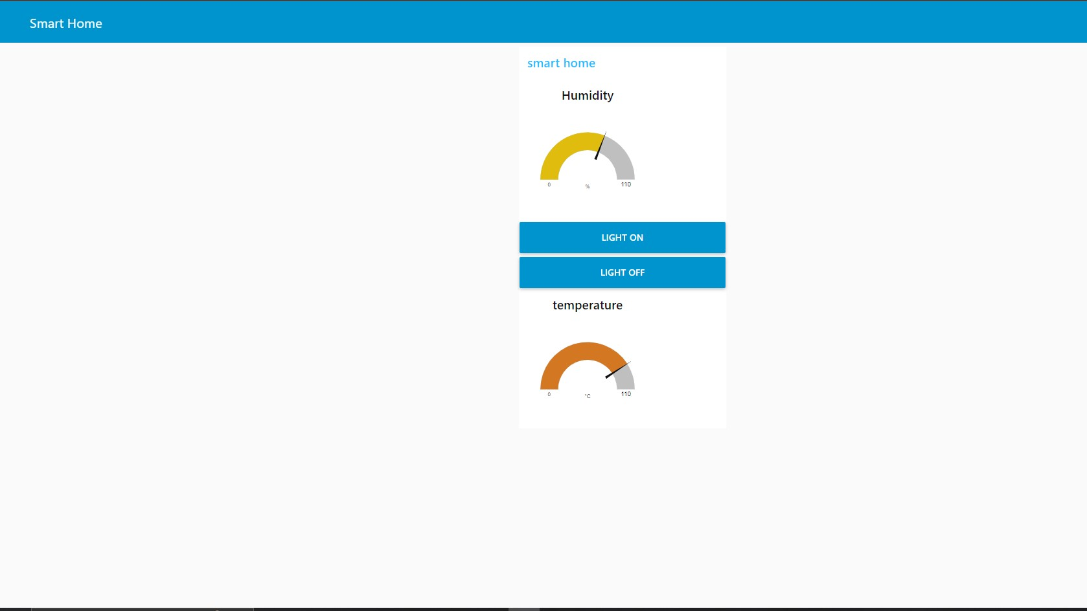

After the successful simulation of the Node-Red Service, User Interface is created. Web UI includes Temp value, Humidity value , in accordance with Switch Board of Light ON and OFF.

# NODE-RED DATA SOURCE

